**Assignment – 1**

I successfully installed Power BI Desktop and the screen shot of the Report view is shown below:

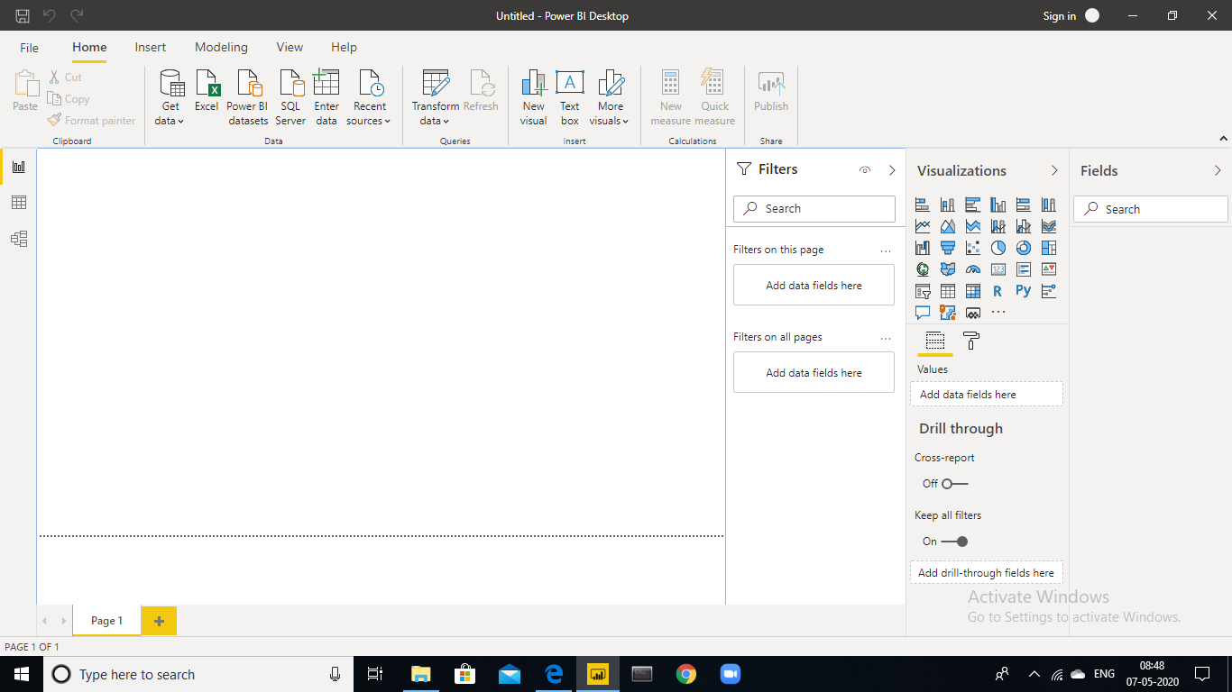

In Power BI Desktop, you can view your dataset in three types of views. You will find the three view options on the left vertical pane of the Power BI Desktop:

**Report view:**

In the report view, we have an empty canvas where we can create a report using data from our datasets. We can make a report of multiple pages and add visualizations in them. So, report view is all about designing your report for data analysis.

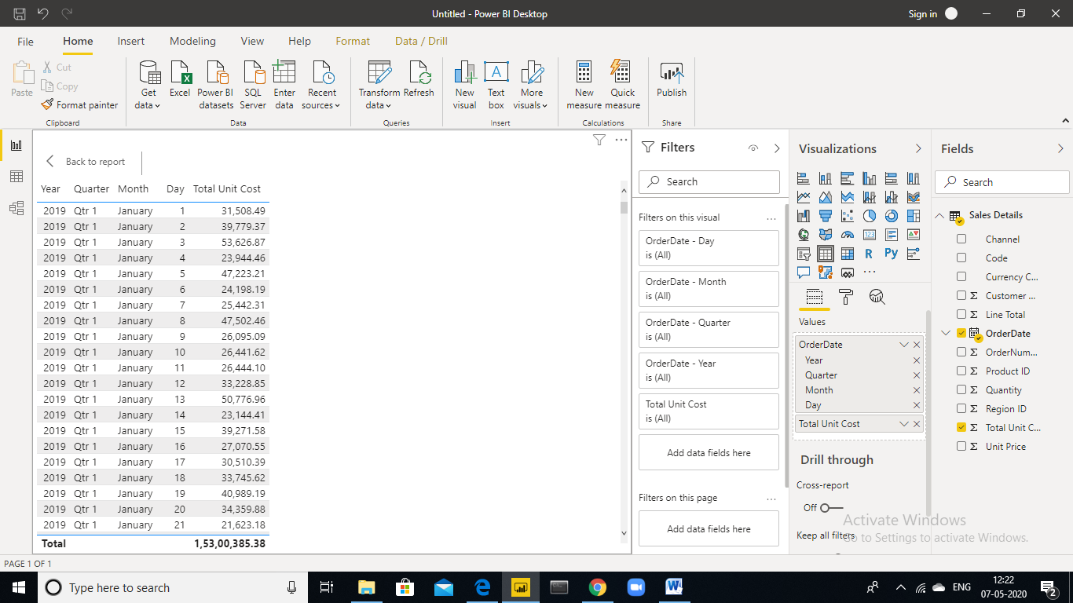

**Report View**

**Screen short of Report View**

**Data view:**

In the data view, we can view and format the data tables in our data set.

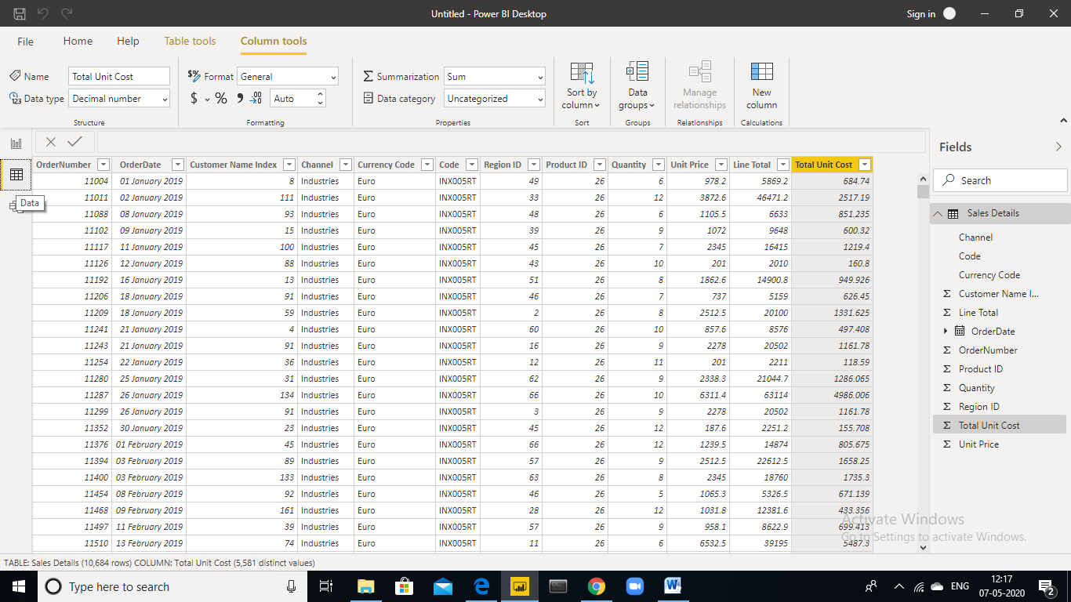

**Data view**

**Screen short of Data View**

**Model view:**

In the model view, we can make data models by establishing relationships between data tables. These associations make the reports more interactive and responsive.

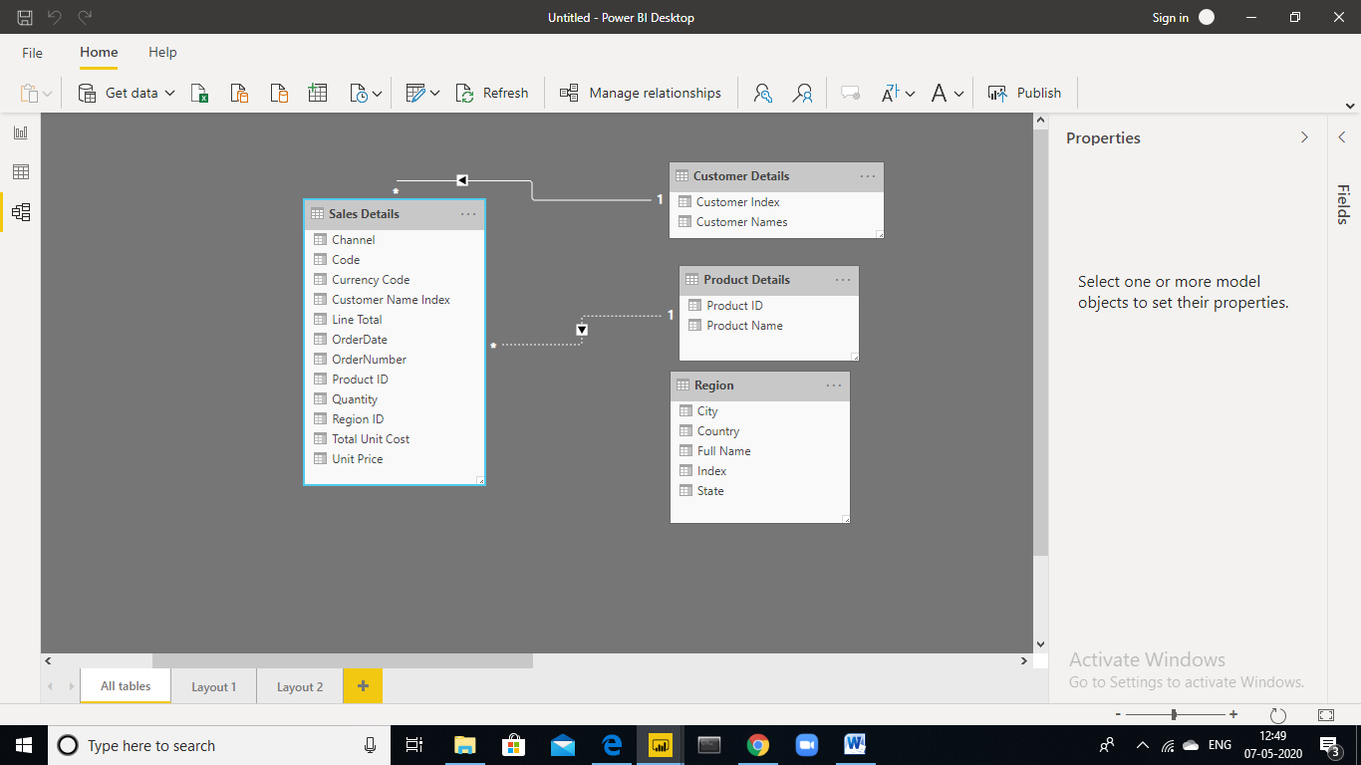

**Screenshot of model view**

**Power Query Editor:**

Power Query Editor is an Excel add-on. It is a self-service ETL tool (Extract, Transform and Load) which is used to import data, transform, shape/clean data and load it for analysis. Power Query provides an interactive user interface to manage and work with data. We can import data from multiple data sources such as datasets databases, social media, etc. We can join data from different sources and make one single dataset. Also, we can transform the data by adding, removing and shaping our datasets as per our requirement.

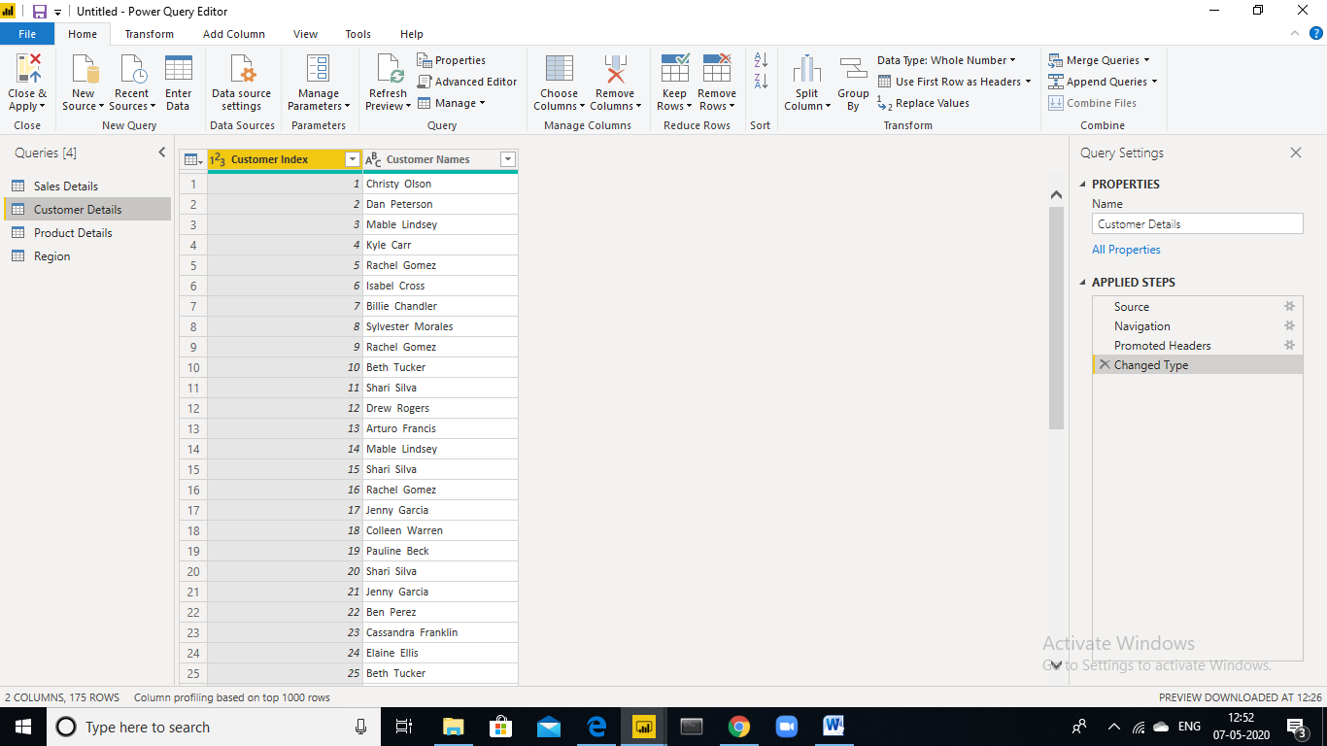

**Screen shot of Power Query Editor**

**Advanced Editor:**

The transformations we made in power query editor we can check the syntax of the query by using advanced editor

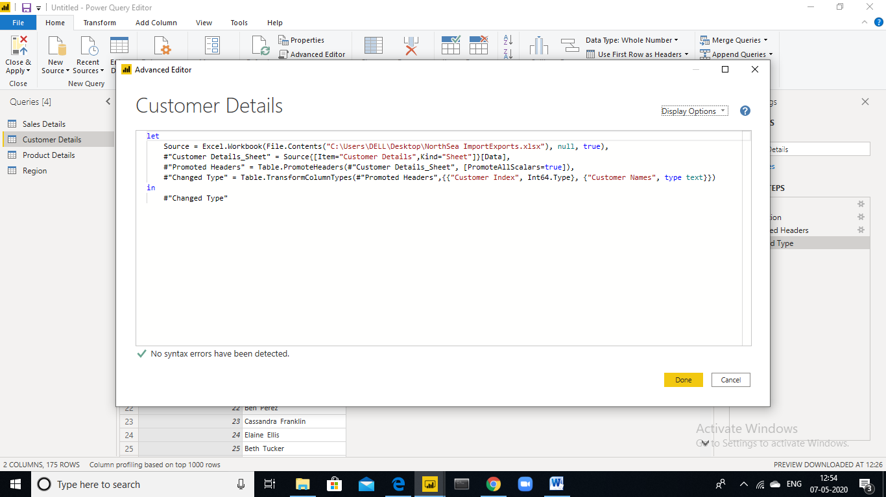

**Screen shot of Advanced Editor**

**Power BI Pricing**

The prices of different versions with their features in this Power BI tutorial. Microsoft has put out three pricing plans for Power BI:

The**basic version**, Power BI Desktop is *free of cost* and includes tools for data visualization, data preparation, data modeling, data cleansing and publishing reports to Power BI Service.

* **Power BI Pro** is available at a subscription price of *Rs.759.34/-* per user per month. We can try a 60 days free trial before purchasing the subscription. This plan for Power BI Pro includes tools for data collaboration, a 360 real-time view for dashboards, data governance, and the freedom to publish reports anywhere.
* The **Power BI Premium** is available at a price of *Rs.3,79,669.95/-* per month for one dedicated storage resource and cloud computing facility.